November 26, 2018

City* City Council

RE: Sunset Provisions on Temporary Commercial Cannabis Licensing Set for December 31, 2018 and the Need for Immediate Resolution

Dear Councilmembers,

This firm represents several licensed commercial cannabis operators and businesses navigating local and state licensing processes. Many of our well-funded, experience driven commercial cannabis businesses are looking to expand their operations, specifically with an interest in exploring mutually beneficial opportunities in the City of City*.

We write to you today to urge you to place an item on the agenda for the next City* City Council immediately, even if on an emergency basis, regarding the urgent need for City* to adopt an emergency ordinance or resolution allowing for commercial cannabis activities within City*.

Following the November 6, 2018 election, we noticed that the voters of City* enacted a commercial cannabis tax measure. In order for City* to realize the benefits of commercial cannabis activities within its borders in 2019, including revenue generated by the newly enacted tax, immediate action will need to be taken that allow applicants and would-be applicants to secure the necessary local approval from the City of City necessary to operate legally.

A license from the State of California is required before a commercial cannabis business is able to commence operations. Unfortunately, Proposition 64 precludes issuance or extension of any temporary license after December 31, 2018. Unless the cannabis applicants in City* can secure some sort of conditional local approval or verification that the applicant is working through the process of licensing and permitting, the current applicants will be unable to operate until they obtain an annual license from the State. To date, the Bureau of Cannabis Control has not issued a single annual license.

Before going into the details you will need to support what we hope will be an obvious decision, we want to give you the bottom line: if applicants in City* do not have a local authorization, even if only conditional, by early December 2018, it is extremely likely that these businesses will not be allowed to legally operate until late 2019, or even 2020. On October 23, 2018, Nevada County resolved this problem by way of simple resolution and a temporary approval process, which is described at the conclusion of this letter. Since that time, we have worked with other cities who are supportive of the temporary approval process below; we expect to see a number of cities issue local approvals in the upcoming weeks.

Temporary commercial cannabis licenses may only be issued until December 31, 2018; this is not open to legislative or regulatory amendment, it is set in stone due to Prop 64. Without local approval, commercial cannabis businesses cannot apply for or obtain a State issued temporary license.

Without a temporary license before December 31, 2018, cannabis businesses who obtain local approval in 2019 are completely ineligible for temporary or provisional licenses from the State of California and must wait until their annual license is issued before they will be able to operate. To date, the three licensing agencies have only issued a handful licenses.

Due to the backlog of applications currently on file with the State’s three licensing agencies, on October 23, 2018 at the California Cannabis Business Conference, Chief Lori Ajax stated unambiguously that cannabis businesses who do not have their temporary license applications filed by December 15, 2018 would not likely receive a temporary license. On October 25, 2018, CalCannabis, who licenses commercial cannabis cultivators, issued a public statement that commercial cannabis businesses who do not have their temporary license application filed with CalCannabis by December 1, 2018, will most likely not receive a temporary license. On October 31, 2018, the California Department of Public Health issued the identical statement, indicating that unless applicants submit a temporary license application by December 1, 2018, the California Department of Public Health is unlikely to issue the temporary license by December 31, 2018.

Temporary Licenses Issued Pursuant to MAUCRSA

Under California Business & Professions Code section 26050.1 (enacted pursuant to Prop 64), the licensing agencies are authorized to issue temporary licenses until December 31, 2018. The agencies have determined that this means they cannot extend the temporary license after January 1, 2019.

These temporary licenses are initially valid for 120 days. That means, if an applicant secures a license on December 1, 2018, it will expire on March 31, 2019. As long as the annual license application is complete and submitted, and the application fees paid before the expiration date, temporary licensees will be eligible for the newly created provisional license, which we discuss below.

So that you are aware, below is a summary of the three agencies’ requirements for temporary license applicants.

If issued by the BCC (retail, microbusiness, distribution, testing), the requirements are:
- temporary license application
- local approval
- landlord consent that the applicant is authorized to occupy the property AND engage in the SPECIFIC cannabis activity for which the applicant is applying
- meet certain premises conditions, such as separate entrances
- Premises Diagram
If issued by CalCannabis (cultivation), the requirements are:
- temporary license application
- local approval
- a proposed cultivation plan
- identification of the water sources to be used for cultivation activities
- evidence of enrollment with the Water Resources Control Board or written exemption therefrom
If issued by CDPH - Manufactured Cannabis Branch, the requirements are:
- temporary license application
- local approval

Provisional Licenses Pursuant to SB1459 (Cal. Bus. & Prof. Code §26050.2)

Given the backlog of annual license applications, California had no choice but to address the fact that temporary licenses are only authorized through December 31, 2018 and that operators would effectively be forced to close their doors waiting for their annual licenses to be issued.

Currently, under Business & Professions Code §26050.1, the last day for any of the three licensing agencies will be December 31, 2018 to issue or extend a temporary license. Given that the temporary licenses are only valid for 120 days, come April 2019, California would be looking at a serious problem. In early November, the BCC issued its first round of annual licenses (10 retail, 1 distributor and 1 event organizer) and CalCannabis issued two (2) cultivation licenses; California Department of Public Health has not issued any annual licenses to date. To date the BCC has received approximately 4,000 applications, CalCannabis has approximately 2,400 waiting for review and California Department of Public Health has approximately 400 applications filed. Each day that goes by, these numbers will increase.

To that end, SB 1459 was signed into law on September 27, 2018 which added Business & Professions Code §26050.2, which will allow the three agencies to issue "Provisional Licenses" to cannabis businesses through 2019. However, there are significant constraints on the agencies' ability to issue these provisional licenses:

- The applicant must already hold or have held a temporary license (issued prior to December 31, 2018).
- The provisional license sought must be for the SAME activity on the SAME premises as authorized by the temporary license.
- The applicant must have submitted a complete annual application, including evidence of CEQA compliance or evidence that CEQA compliance is underway.
In sum, the provisional license does not solve he temporary license problem, it solves the annual license problem for existing temporary license holders. That temporary license is the key to operations in 2019.

Delays Could Bankrupt Cannabis Businesses, Cause Property Foreclosures and Expose the City of City* to Adverse Legal Action

While we wholeheartedly understand the need for local governments to maintain control over the permitting and licensing processes within their jurisdiction, due to the dual-licensing framework created by Prop 64 and MAUCRSA, cannabis businesses navigating the local legal application process are extremely vulnerable to financial losses caused by the subset provisions on temporary licensing and the inability to secure a local approval.

Narrow zoning ordinances create limited real estate opportunities for cannabis businesses seeking to operate legally. In turn, landlords have capitalized on this scarcity, charging as high as triple market rates for bare bones, hardly improved properties. Those businesses fortunate enough to locate property for sale are paying two and three times the prior year’s appraised value. This creates an enormous financial burden for cannabis businesses seeking to become licensed.

On the conservative side, a business may pay $10,000 per month for rent. If those businesses have been trying to become legal since the beginning of the year, they are approaching the $120,000 mark in rent alone.

If City* does not issue a local approval so these businesses can obtain a temporary license by the end of the year, they are looking at another $120,000 in rents for next year, for a total of $240,000 with absolutely no ability to generate income legally.

We are aware of operators who have been forced to walk away from their properties lost to foreclosure or eviction throughout the State. Other companies have decided to return to the black market. Others still have made the tough decision to uproot their families and move elsewhere.

Currently there are several cities and counties throughout California who are in active litigation because they accepted fees from applicants who are faced with delays and no real available pathway to becoming legal in the next year or year and a half.

We mention this to simply highlight just how important this issue is and will likely become throughout California as we head into next year.

The Cities of Los Angeles, Long Beach and San Deigo and Nevada County’s Simple Solution

We have been encouraging local officials to adopt emergency ordinances or resolutions so that operators can secure temporary licenses they need to be eligible for a provisional license in 2019. We hope that City* is open to ensuring that the commercial cannabis businesses who have dedicated themselves to becoming legal are able to operate in 2019.

On October 23, 2018, Nevada County's Board of Supervisors made the bold move to adopt a resolution that will allow would-be operators to apply for a conditional approval from the County so they can secure the temporary license.

For convenience, we have attached the information put out thus far by Nevada County for your review and consideration. We have also attached a sample local approval letter for your review.

On November 8, 2018, the City of Los Angeles also released an announcement that it will be issuing temporary and conditional approval letters to the applicants working their way through the local approval process in Los Angeles. The City of Los Angeles has in fact now issued local approval letters.

Long Beach and San Diego have also issued conditional local authorization letters to be used by applicants to secure a temporary license, which will allow them to participate in the commercial cannabis industry once all local approvals have been secured.

In conclusion, we strongly urge you to take immediate action to honor the directive of the voters and the applicants who want nothing other than to operate legally.

We are not asking that you immediately allow for cannabis activity in the City of City*, rather that you simply preserve the opportunity for those who are eventually approved to operate in 2019. We are happy to discuss this matter with you at length by phone, in an in-person meeting or even provide a presentation at your next meeting.

We thank you in advance for your careful consideration of this important issue.

Sincerely,

SAMPLE LOCAL APPROVAL LETTER

Date

Applicant Name
Applicant Address
Applicant City, CA Zip

RE: Conditional Approval to Operate Commercial Cannabis Distribution Facility in City of City*

Dear Applicant:

The City Council of City* has received and reviewed your application for commercial cannabis activities located at ___________________________. This letter shall serve as your local approval necessary to obtain a temporary commercial cannabis [insert license type, e.g. Retail (Type 10) or Medium Indoor Cultivation (Type 3B), or Volatile Manufacturing (Type 7), etc.] (hereinafter the “Commercial Cannabis Activity” or “Commercial Cannabis Activities”) subject to the conditions below:
1. A Conditional Use Permit shall be applied for and approved prior to commencement of any Commercial Cannabis Activities.
2. A development agreement shall be executed, adopted and effective prior to commencement of any Commercial Cannabis Activities.
3. The City Council shall grant the final approval prior to commencement of any Commercial Cannabis Activities.
4. The applicant and/or employees of this establishment shall grant access to City inspectors and personnel, as designees of the City Manager, upon request.
5. Access by the City Council or its designees shall also be granted to the live video recordings of the operations at this location as they relate to the any Commercial Cannabis Activities.
6. The applicant and operation shall continually remain in compliance with all City* Codes, Regulations, Ordinances and applicable State laws.
7. Nothing herein shall be construed as vesting any rights in the applicant to engage in any Commercial Cannabis Activity until the above conditions and any other conditions of approval have been satisfied and no operations of any Commercial Cannabis Activities shall commence or continue unless and until the City of City* issues a final approval [or permit or license or certificate of occupancy has or have been issued].
8. By your signature below, you are agreeing to the conditions and terms of this authorization. Failure to comply with the conditions of this permit and other applicable regulations, will result in revocation of this authorization.
If you have any questions please do not hesitate to contact me.

Sincerely,

City* City Council

Acknowledged and Agreed:

_______________________
Applicant

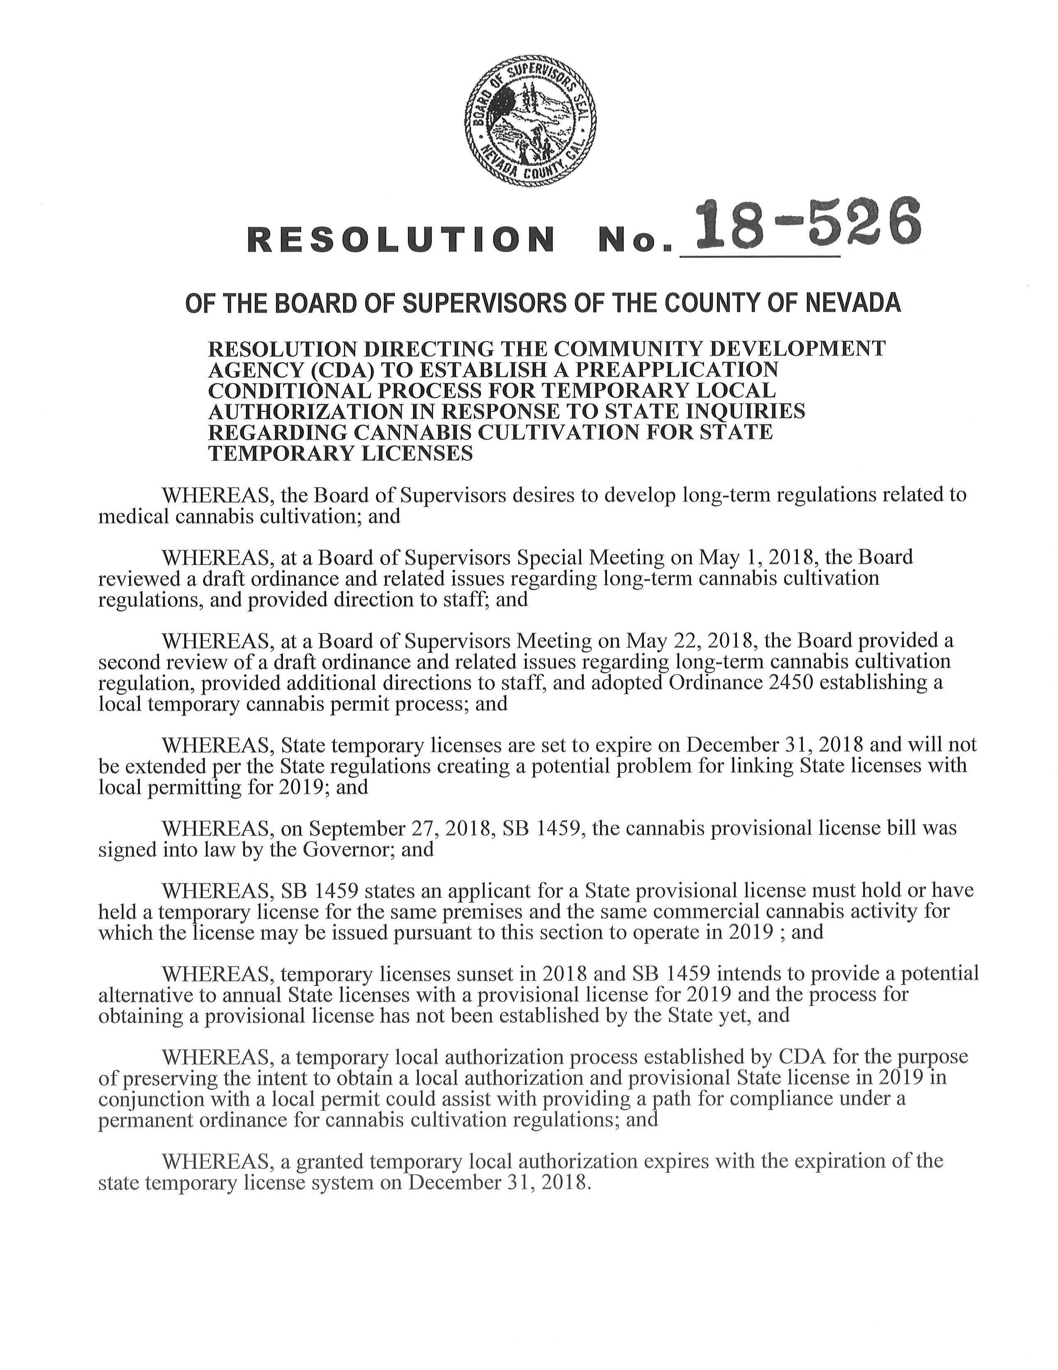
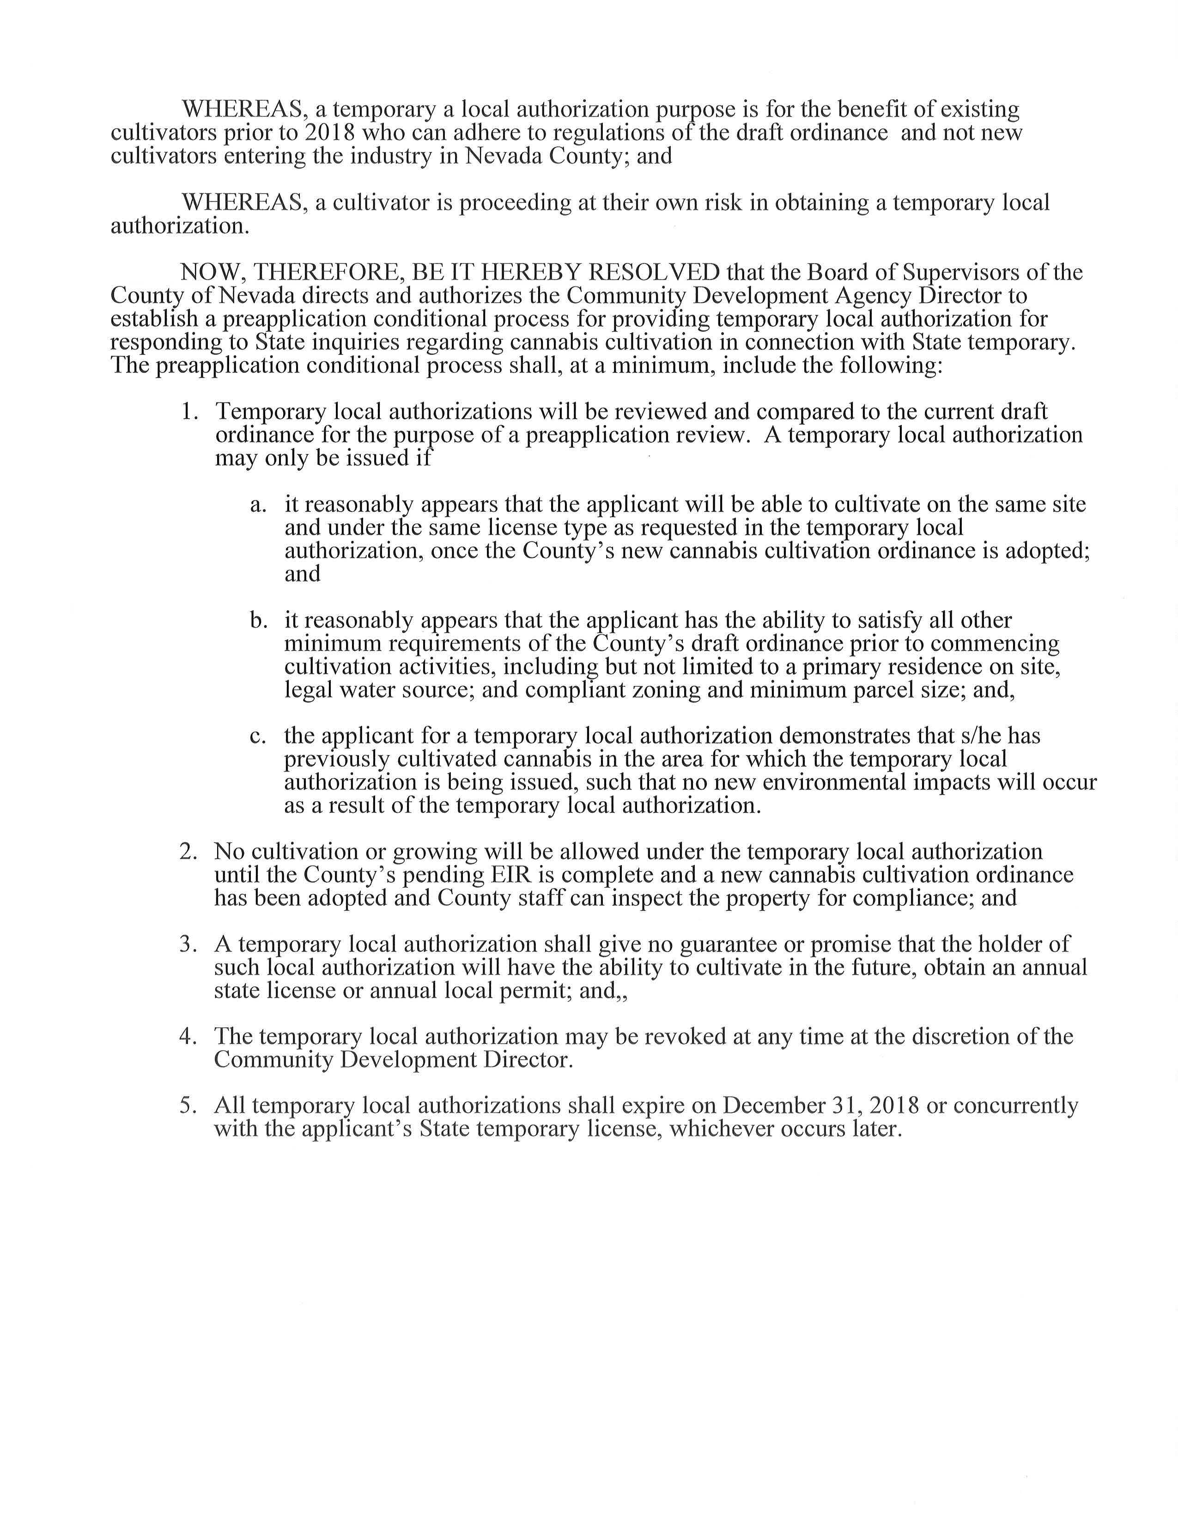
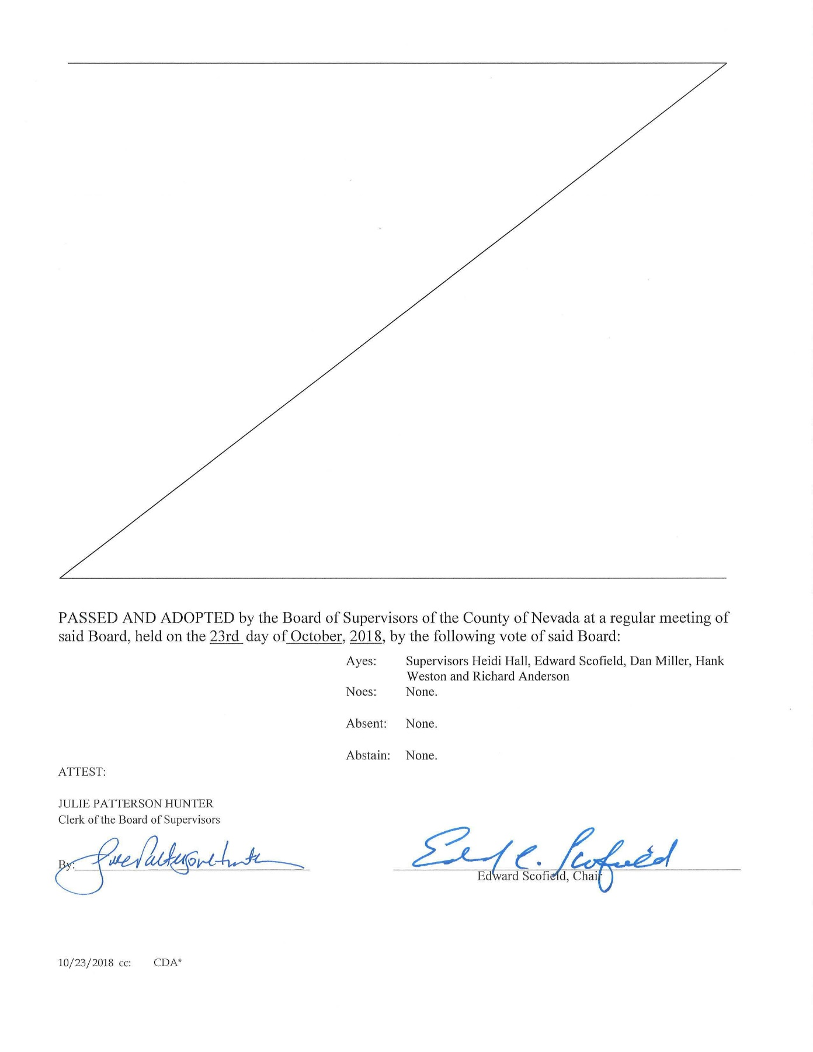
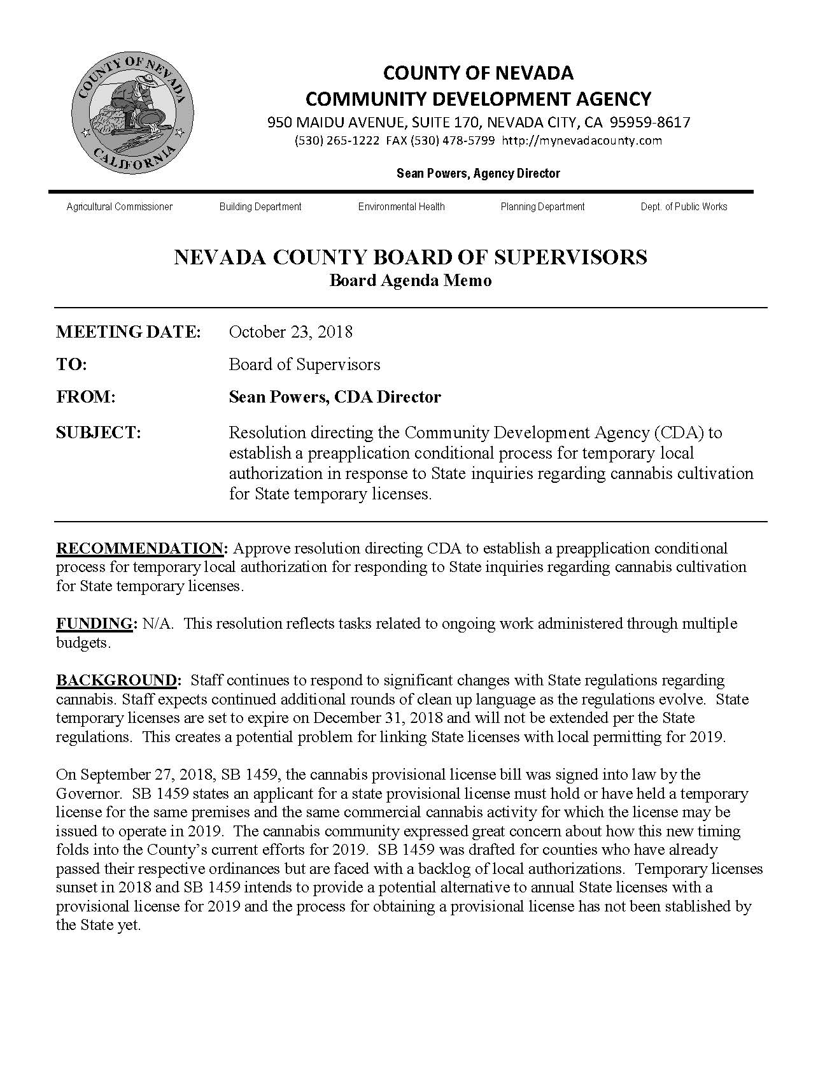
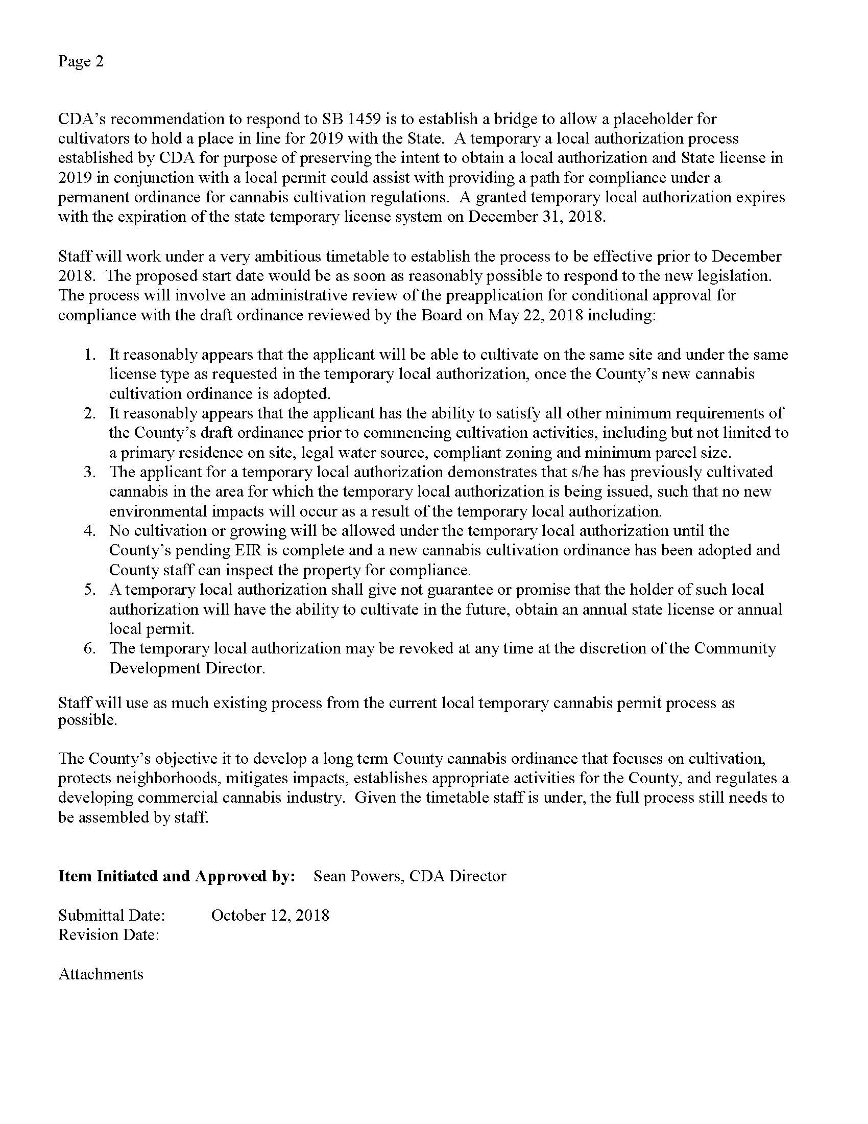
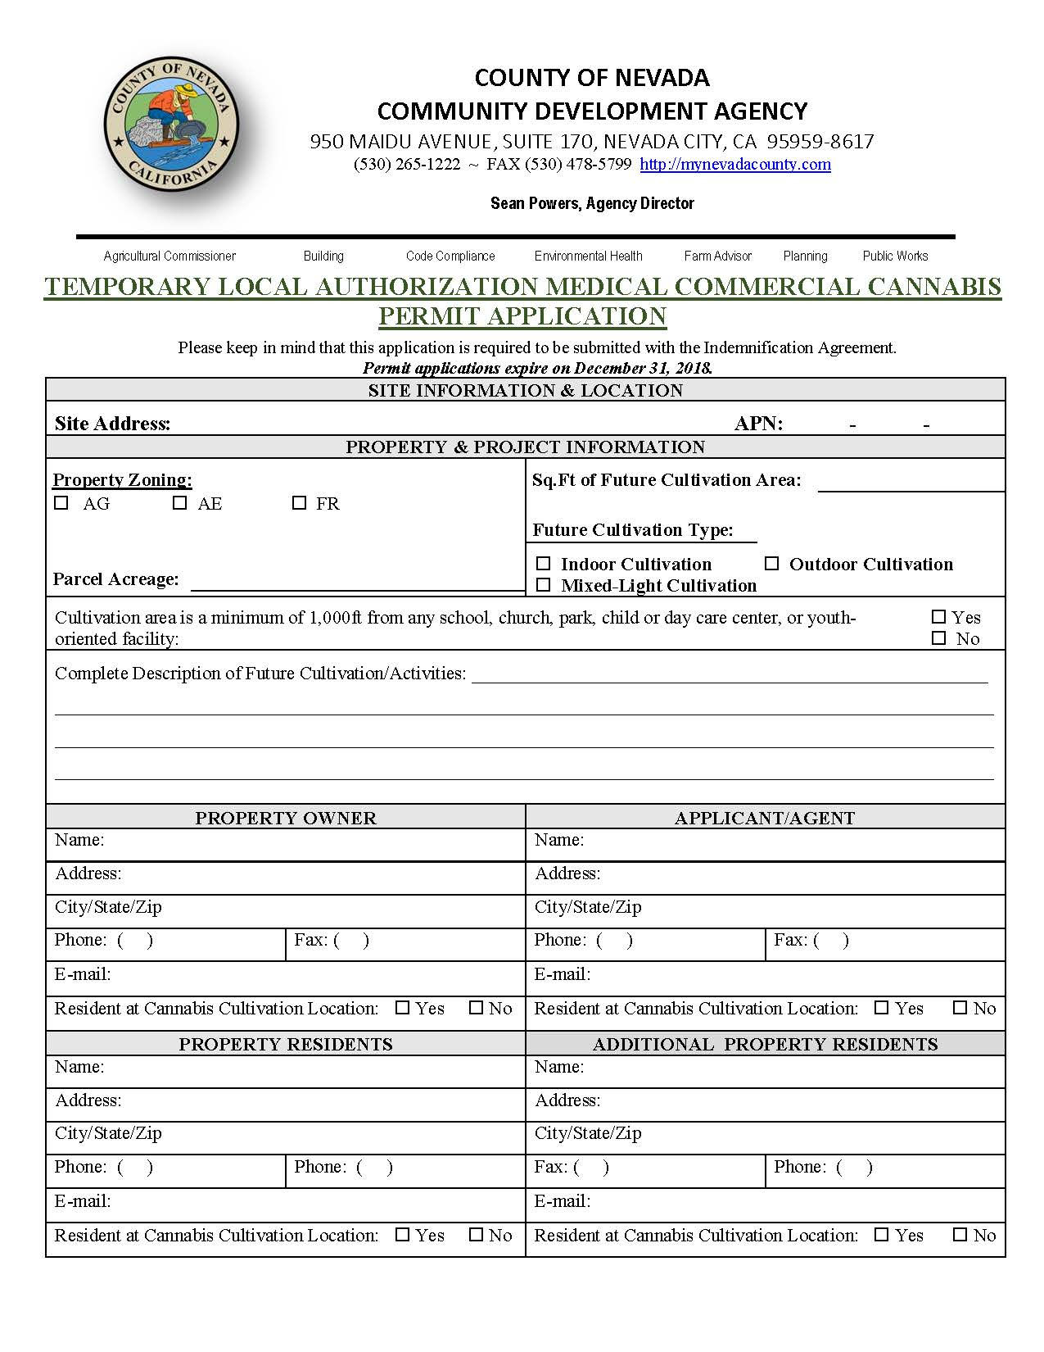
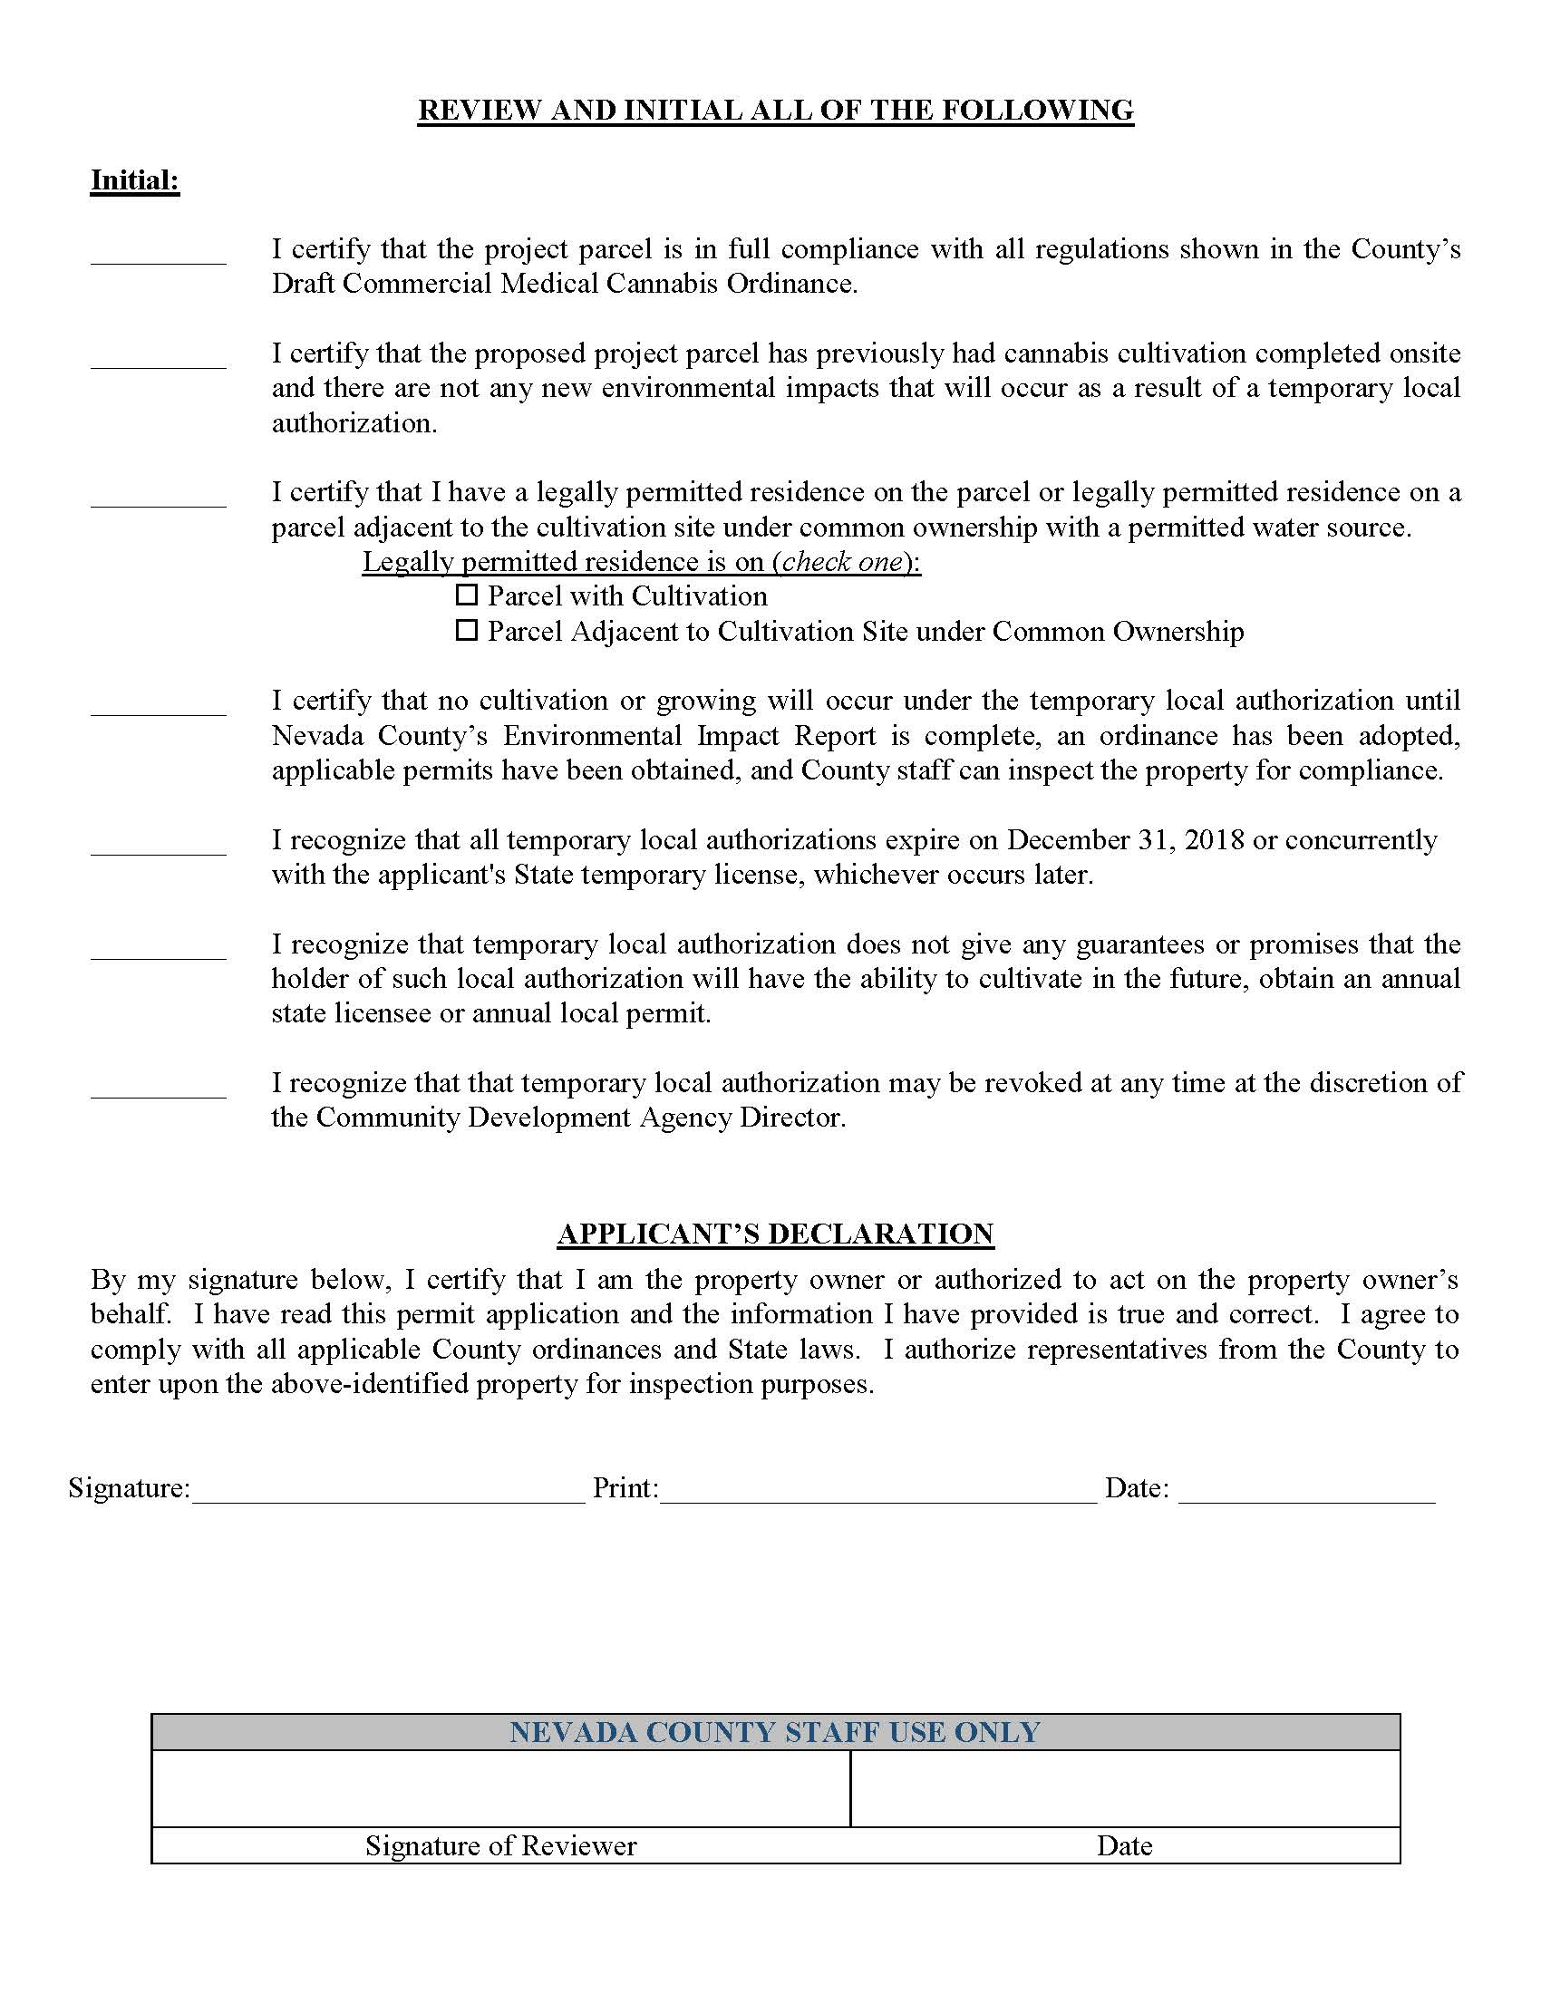
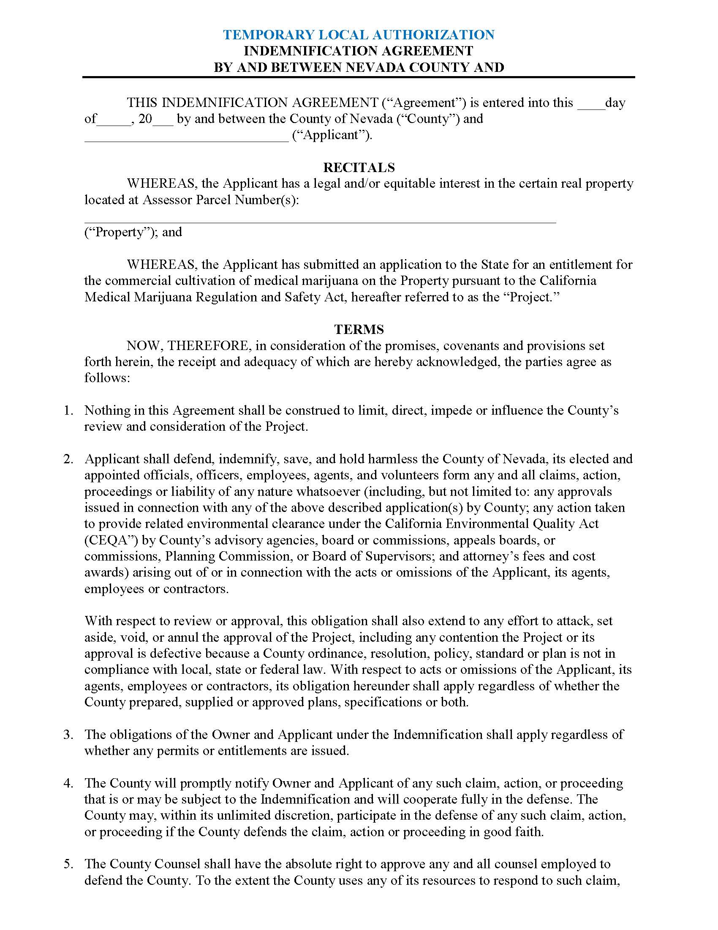
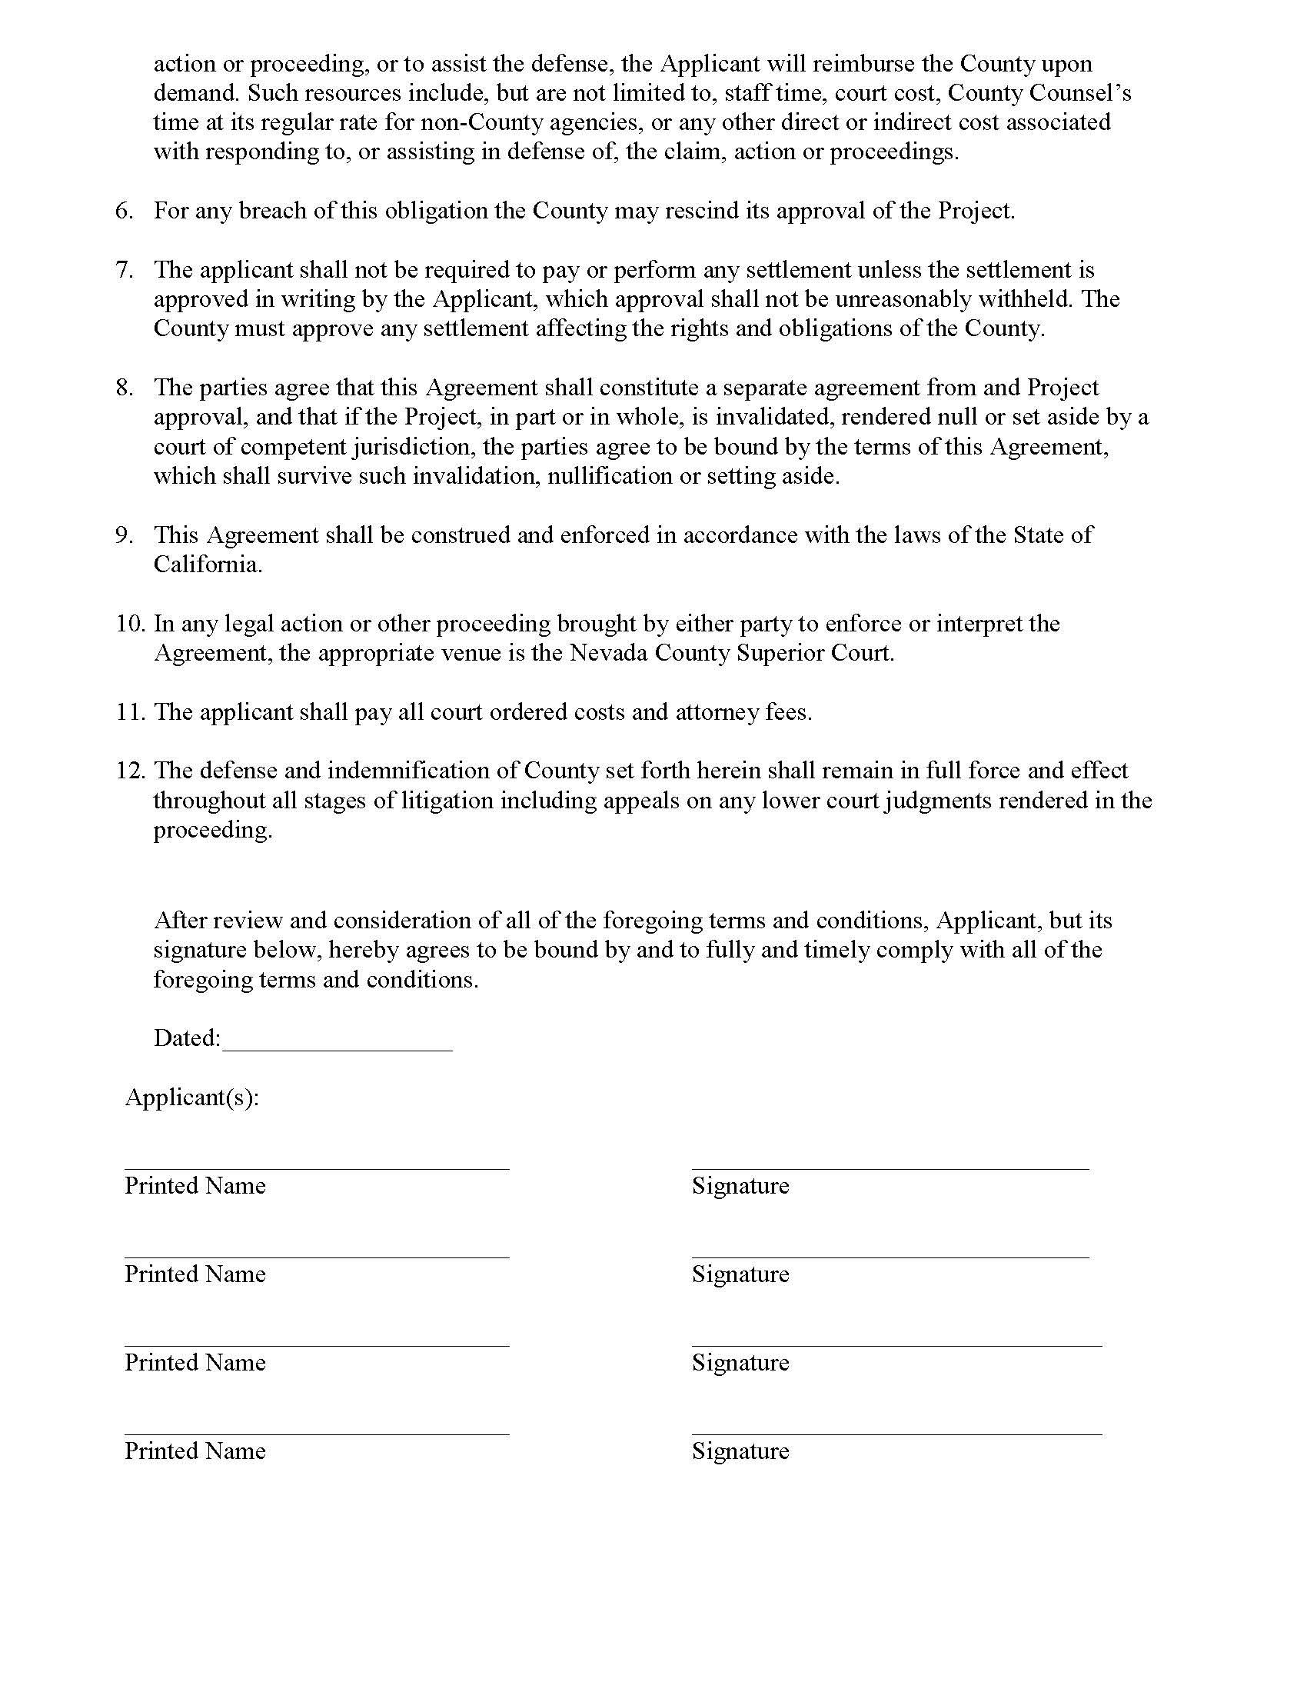

Temporary licenses are eligible for 90-day extensions as long as the applicant has submitted the annual license application. These 90-day extensions also sunset on December 31, 2018, although expiration dates may go into 2019, but temporary licenses cannot be extended in 2019.
https://cannabis.lacity.org/

