October 26, 2018

Hon. Mayor ____
[or]
Hon. City Council
[or]
Hon. Board of Supervisors
[or]
City Manager
City/County
Address1
Address 2
City, CA Zip

RE: Sunset Provisions on Temporary Commercial Cannabis Licensing Set for December 31, 2018 and the Need for Immediate Resolution

Dear ______________,

We are writing to you today to urge you to call a Special Meeting of the [City Council or Board of Supervisors] or to put an item on your agenda immediately, even if on an emergency basis regarding temporary licenses issued by the State of California for commercial cannabis activities.

Before going into the details you will need to support what we hope will be an obvious decision, we want to give you the bottom line: If applicants in your [city or county] do not have a local authorization, even if only conditional, by early December 2018, it is extremely likely that these businesses will not be allowed to legally operate until late 2019, or even 2020. On October 23, 2018, Nevada County resolved this problem by way of simple resolution and a temporary approval process, which is described at the conclusion of this letter.

Temporary commercial cannabis licenses may only be issued until December 31, 2018; this is not open to legislative or regulatory amendment, it is set in stone. Without local approval, commercial cannabis businesses cannot apply for or obtain a State issue temporary license.

Without a temporary license before December 31, 2018, cannabis businesses who obtain local approval in 2019 are completely ineligible for temporary or provisional licenses from the State of California and must wait until their annual license is issued before they will be able to operate. To date, California has not issued a single annual license.

Due to the backlog of applications currently on file with the State’s three licensing agencies, on October 23, 2018 at the California Cannabis Business Conference, Chief Lori Ajax stated unambiguously that cannabis businesses who do not have their temporary license applications filed by December 15, 2018 would not likely receive a temporary license. On October 25, 2018, CalCannabis, who licenses commercial cannabis cultivators, issued a public statement that commercial cannabis businesses who do not have their temporary license application filed with CalCannabis by December 1, 2018, will most likely not receive a temporary license.

Temporary Licenses Issued Pursuant to MAUCRSA

Under California Business & Professions Code section 26050.1 (enacted pursuant to Prop 64), the licensing agencies are authorized to issue temporary licenses until December 31, 2018. The agencies have determined that this means they cannot extend the temporary license after January 1, 2019.

These temporary licenses are initially valid for 120 days. That means, if an applicant secures a license on December 1, 2018, it will expire on March 31, 2019. As long as the annual license application is complete and submitted, and the application fees paid before the expiration date, temporary licensees will be eligible for the newly created provisional license, which we discuss below.

So that you are aware, below is a summary of the three agencies’ requirements for temporary license applicants:

If issued by the BCC (retail, microbusiness, distribution, testing), the requirements are:
- temporary license application
- local approval
- landlord consent that the applicant is authorized to occupy the property AND engage in the SPECIFIC cannabis activity for which the applicant is applying
- meet certain premises conditions, such as separate entrances
- Premises Diagram
If issued by CalCannabis (cultivation), the requirements are:
- temporary license application
- local approval
- a proposed cultivation plan
- identification of the water sources to be used for cultivation activities
- evidence of enrollment with the Water Resources Control Board or written exemption therefrom
If issued by CDPH - Manufactured Cannabis Branch, the requirements are:
- temporary license application
- local approval
Provisional Licenses Pursuant to SB1459 (Cal. Bus. & Prof. Code §26050.2)

Given the backlog of annual license applications, California had no choice but to address the fact that temporary licenses are only authorized through December 31, 2018 and that operators would effectively be forced to close their doors waiting for their annual licenses to be issued.

Currently, under Business & Professions Code §26050.1, the last day for any of the three licensing agencies will be December 31, 2018 to issue or extend a temporary license. Given that the temporary licenses are only valid for 120 days, come April 2019, California would be looking at a serious problem. To date, no annual licenses have been issued.

To that end, SB 1459 was signed into law on September 27, 2018 which added Business & Professions Code §26050.2, which will allow the three agencies to issue "Provisional Licenses" to cannabis businesses through 2019. However, there are significant constraints on the agencies' ability to issue these provisional licenses:

- The applicant must already hold or have held a temporary license (issued prior to December 31, 2018).
- The provisional license sought must be for the SAME activity on the SAME premises as authorized by the temporary license.
- The applicant must have submitted a complete annual application, including evidence of CEQA compliance or evidence that CEQA compliance is underway.
In sum, the provisional license does not solve he temporary license problem, it solves the annual license problem for existing temporary license holders. That temporary license is the key to operations in 2019.

Delays Could Bankrupt Cannabis Businesses, Cause Property Foreclosures and Expose the [City or County] to Adverse Legal Action

While we wholeheartedly understand the need for local governments to maintain control over the permitting and licensing processes within their jurisdiction, due to the dual-licensing framework created by Prop 64 and MAUCRSA, cannabis businesses navigating the local legal application process are extremely vulnerable financially.

Narrow zoning ordinances create limited real estate opportunities for cannabis businesses seeking to operate legally. In turn, landlords have capitalized on this scarcity, charging as high as triple market rates for bare bones, hardly improved properties. Those businesses fortunate enough to locate property for sale are paying two and three times the prior year’s appraised value. This creates an enormous financial burden for cannabis businesses seeking to become licensed.

On the conservative side, a business may pay $10,000 per month for rent. If those businesses have been trying to become legal since the beginning of the year, they are approaching the $120,000 mark in rent alone. If the [City or County] does not issue a local approval so these businesses can obtain a temporary license by the end of the year, they are looking at another $120,000 in rents for next year, for a total of $240,000 with absolutely no ability to generate income legally.

We are aware of operators who have been forced to walk away from their properties lost to foreclosure or eviction throughout the State. Other companies have decided to return to the black market. Others still have made the tough decision to uproot their families and move elsewhere.

Currently there are several cities and counties throughout California who are in active litigation because they accepted fees from applicants who are faced with delays and no real or foreseeably soon pathway to becoming legal.

We mention this not as a threat, but to simply highlight just how important this issue is and will likely become throughout California as we head into next year.

Nevada County’s Simple Solution

We have been encouraging local officials to adopt emergency ordinances or resolutions so that operators can secure temporary licenses they need to be eligible for a provisional license in 2019. We hope that the City of _____ is open to ensuring that the commercial cannabis businesses who have dedicated themselves to becoming legal are able to operate in 2019.

On October 23, 2018, Nevada County's Board of Supervisors made the bold move to adopt a resolution that will allow would-be operators to apply for a conditional approval from the County so they can secure the temporary license.

For convenience, we have attached the information thus far put out by Nevada County for your review and consideration.

In conclusion, we strongly urge you to take immediate action to protect the [City or County] and the applicants going through the licensing process who want nothing other than to operate legally.

Sincerely,

Your name here

Enclosures: Staff Report from Nevada County and Temporary Authorization Package
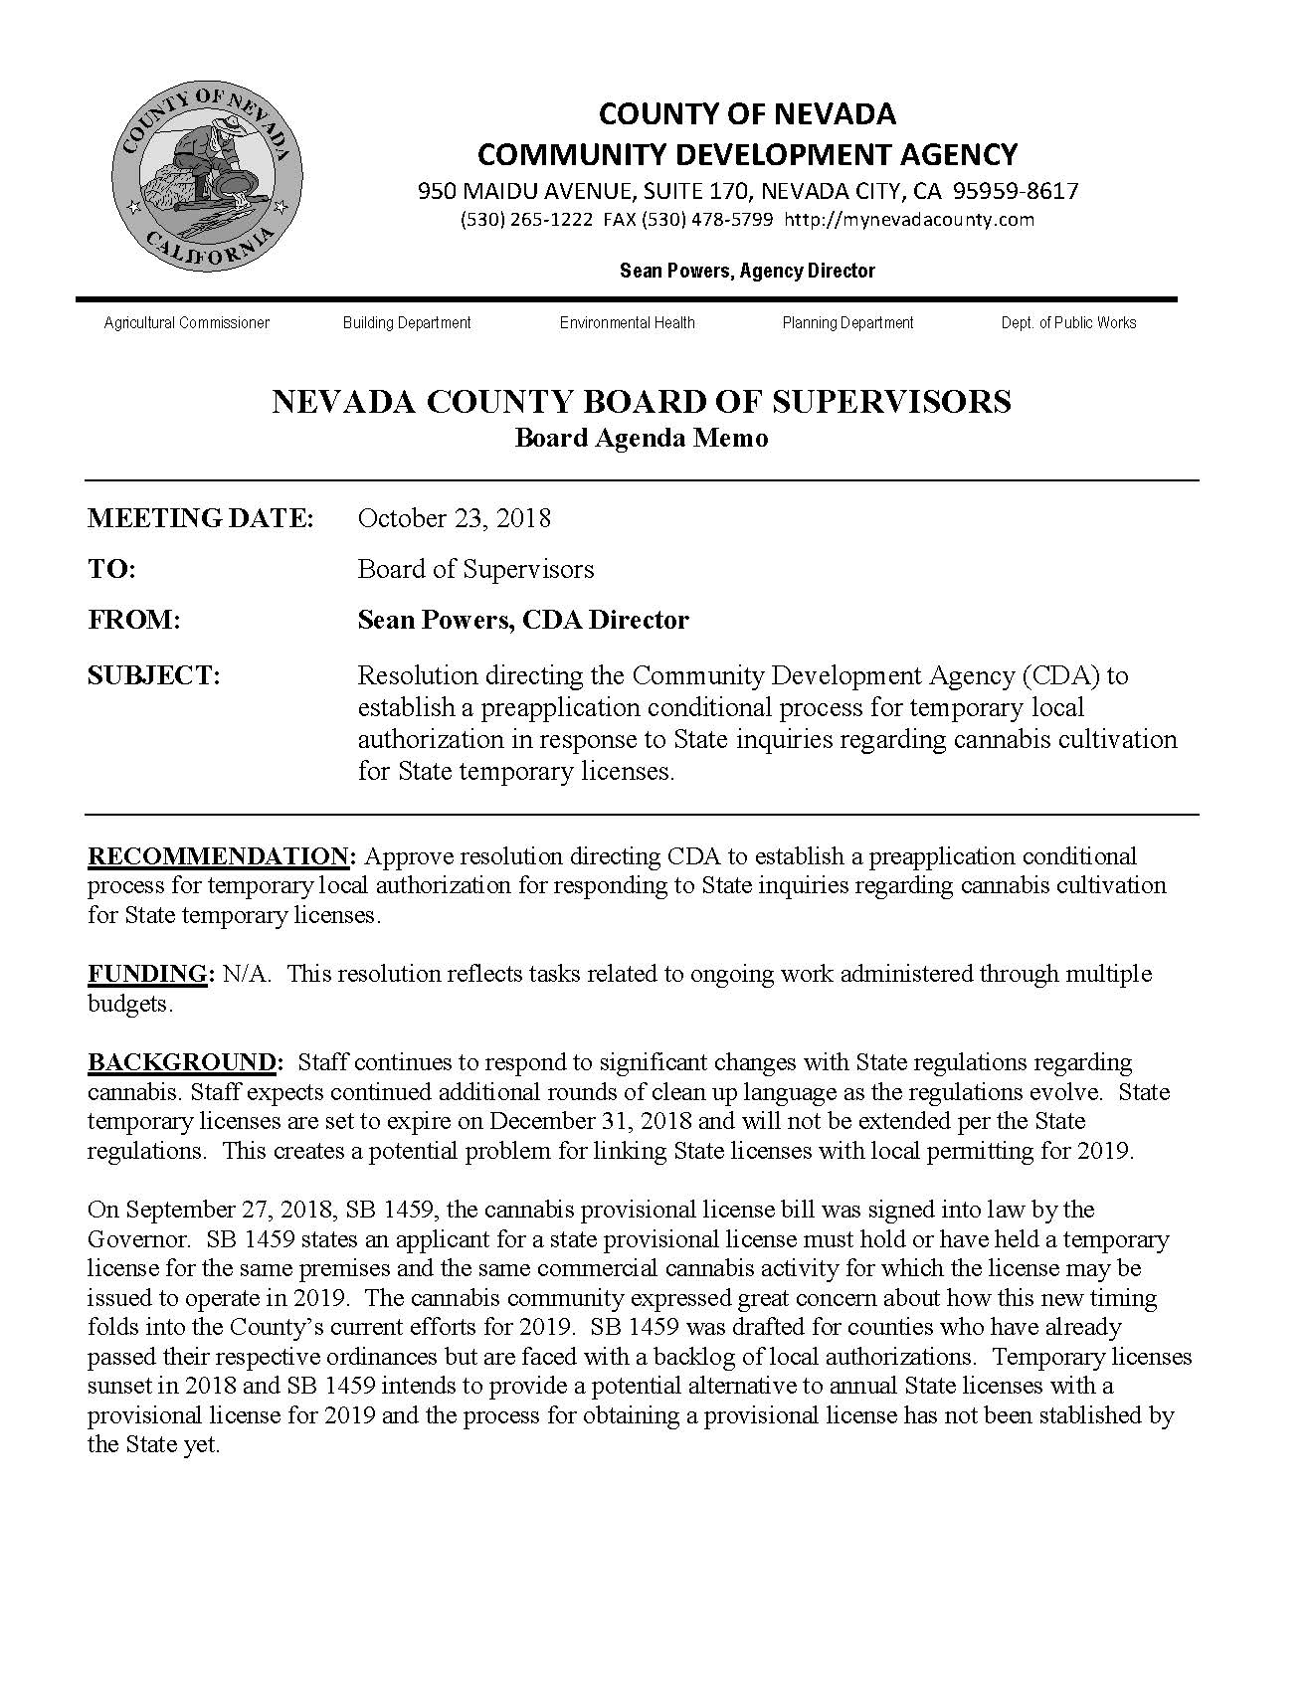
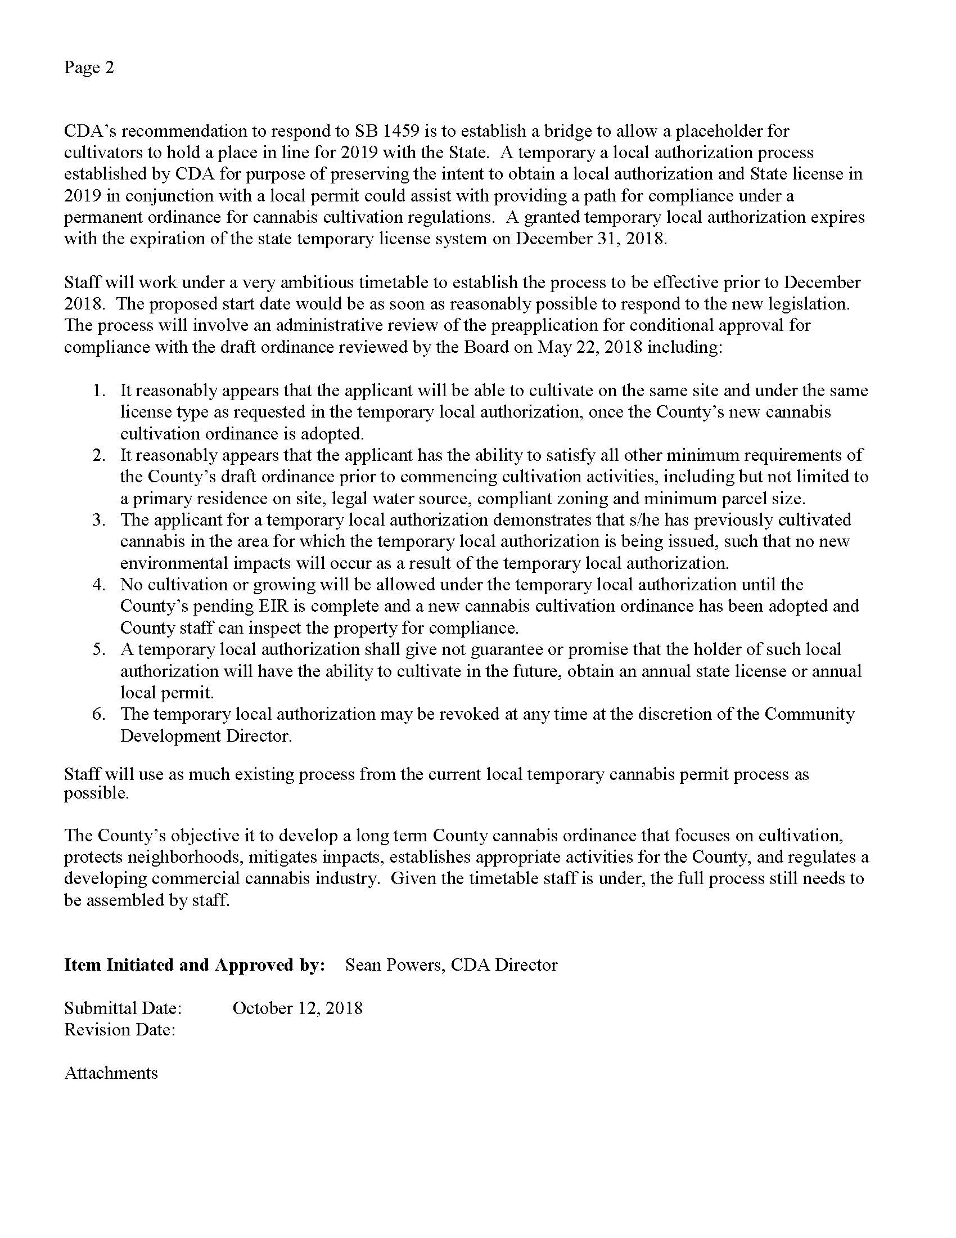
COUNTY OF NEVADA COMMUNITY DEVELOPMENT AGENCY
950 MAIDU AVENUE, SUITE 170, NEVADA CITY, CA 95959-8617
(530) 265-1222 ~ FAX (530) 478-5799 http://mynevadacounty.com

Sean Powers, Agency Director

Agricultural Commissioner Building Code Compliance Environmental Health Farm Advisor Planning Public Works
TEMPORARY LOCAL AUTHORIZATION MEDICAL COMMERCIAL CANNABIS PERMIT APPLICATION
Please keep in mind that this application is required to be submitted with the Indemnification Agreement.
Permit applications expire on December 31, 2018.
SITE INFORMATION & LOCATION

Site Address: APN: - -
PROPERTY & PROJECT INFORMATION

Property Zoning:
□ AG □ AE □ FR

Parcel Acreage:

Sq.Ft of Future Cultivation Area:

Future Cultivation Type:

□ Indoor Cultivation □ Outdoor Cultivation
□ Mixed-Light Cultivation

Cultivation area is a minimum of 1,000ft from any school, church, park, child or day care center, or youth- oriented facility:

□ Yes
□ No

Complete Description of Future Cultivation/Activities:

 | PROPERTY OWNER |  | APPLICANT/AGENT
Name: |  | Name:
Address: |  | Address:
City/State/Zip |  | City/State/Zip
Phone: ( ) | Fax: ( ) | Phone: ( ) | Fax: ( )
E-mail: |  | E-mail:
Resident at Cannabis Cultivation Location: □ Yes □ No Resident at Cannabis Cultivation Location: □ Yes □ No

PROPERTY RESIDENTS ADDITIONAL PROPERTY RESIDENTS
Name: |  | Name:
Address: |  | Address:
City/State/Zip |  | City/State/Zip
Phone: ( ) | Phone: ( ) | Fax: ( ) | Phone: ( )
E-mail: |  | E-mail:
Resident at Cannabis Cultivation Location: □ Yes □ No Resident at Cannabis Cultivation Location: □ Yes □ No

REVIEW AND INITIAL ALL OF THE FOLLOWING

Initial:

I certify that the project parcel is in full compliance with all regulations shown in the County’s
Draft Commercial Medical Cannabis Ordinance.

I certify that the proposed project parcel has previously had cannabis cultivation completed onsite and there are not any new environmental impacts that will occur as a result of a temporary local authorization.

I certify that I have a legally permitted residence on the parcel or legally permitted residence on a parcel adjacent to the cultivation site under common ownership with a permitted water source.
Legally permitted residence is on (check one):
□ Parcel with Cultivation
□ Parcel Adjacent to Cultivation Site under Common Ownership

I certify that no cultivation or growing will occur under the temporary local authorization until Nevada County’s Environmental Impact Report is complete, an ordinance has been adopted, applicable permits have been obtained, and County staff can inspect the property for compliance.

I recognize that all temporary local authorizations expire on December 31, 2018 or concurrently with the applicant's State temporary license, whichever occurs later.

I recognize that temporary local authorization does not give any guarantees or promises that the holder of such local authorization will have the ability to cultivate in the future, obtain an annual state licensee or annual local permit.

I recognize that that temporary local authorization may be revoked at any time at the discretion of the Community Development Agency Director.

APPLICANT’S DECLARATION
By my signature below, I certify that I am the property owner or authorized to act on the property owner’s behalf. I have read this permit application and the information I have provided is true and correct. I agree to comply with all applicable County ordinances and State laws. I authorize representatives from the County to enter upon the above-identified property for inspection purposes.

Signature: Print: Date:

NEVADA COUNTY STAFF USE ONLY
Signature of Reviewer Date

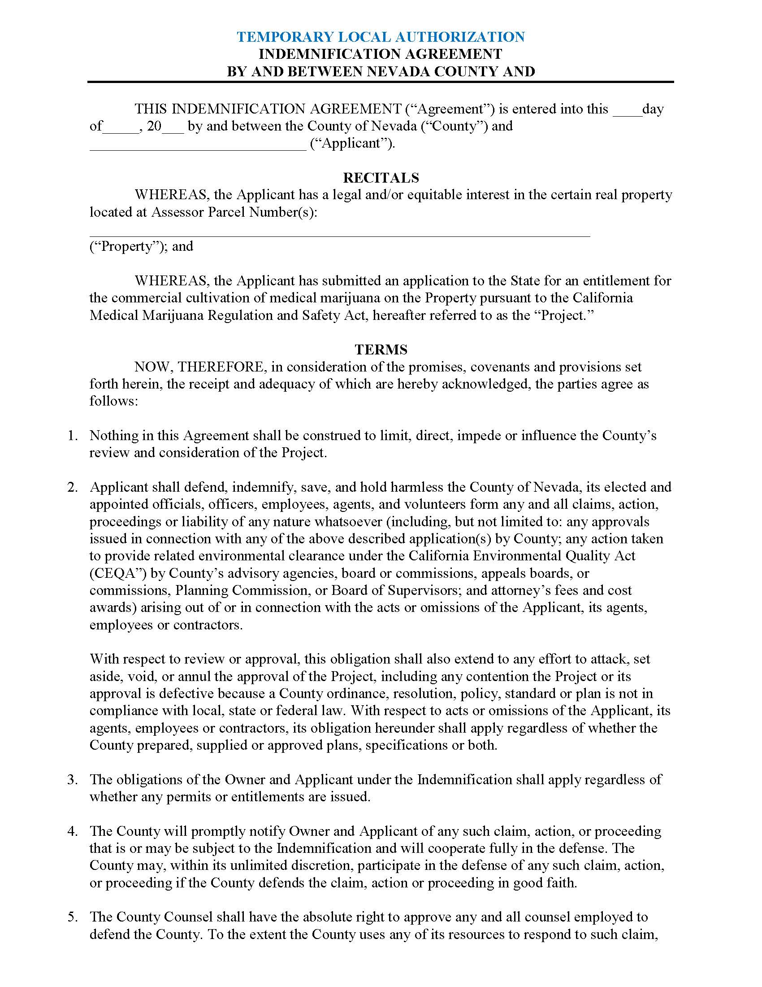
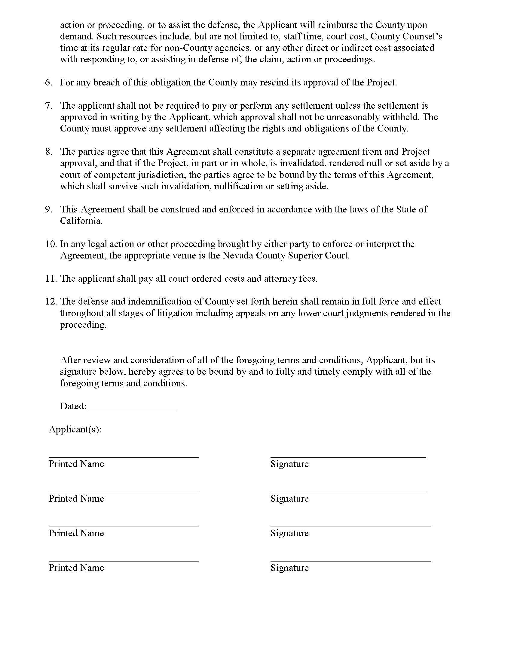

Temporary licenses are eligible for 90-day extensions as long as the applicant has submitted the annual license application. These 90-day extensions also sunset on December 31, 2018, although expiration dates may go into 2019, but temporary licenses cannot be extended in 2019.

